Stand up and fight

Student: ………………………..…………..…..…..…………… Class: …..…….....………. Due date: …..…….…………………...

**By the eleventh century, a new type of soldier was having a big influence on the outcome of a battle.**

**1.** **Compare SOURCES 1 and 2.**

|  |  |  |  |
| --- | --- | --- | --- |
|  | SOURCE 1 The Battle of Maldon, 991 CE: the English tried to repulse a Viking invasion. |  | SOURCE 2 The Battle of Hastings, 1066 CE: the English tried to repulse a Norman invasion. |
|  | 04  The Battle of Maldon, 991, illustration from Hutchinsons Story of the British Nation, c.1923 litho, Pearse, Alfred 19th/20th Century / Private Collection / The Stapleton Collection / Bridgeman Images |  | 04 |

**a.** **What new inventions assisted a soldier in manoeuvring on horseback?**

|  |  |
| --- | --- |
| **i.** |  |
|  |  |
| **ii.** |  |
|  |  |

**b.** **Describe two ways in which these developments would give a soldier an advantage over his enemy.**

|  |  |
| --- | --- |
| **i.** |  |
|  |  |
| **ii.** |  |
|  |  |
|  |  |

**2.** 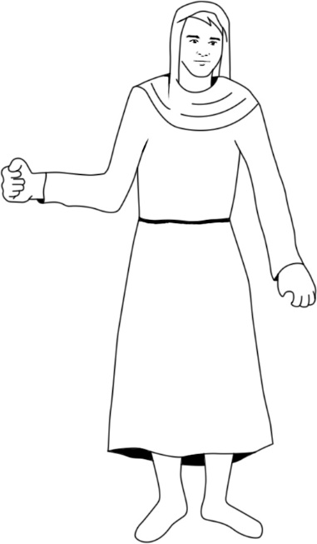**A knight would sometimes take his peasants into battle armed only  
with what they could grab from the farm. Arm this peasant   
appropriately with two items.**

|  |
| --- |
|  |
|  |
|  |
|  |
|  |

**3.** **Monks could also be knights. Who and what do you think they might have   
to protect?** **(*Clue:* Refer to the feudal system diagram from this topic.)**

|  |
| --- |
|  |
|  |
|  |
|  |
|  |
|  |

**4.** **Look carefully at SOURCE 3, which shows the development of the knight’s armour, and then answer the questions.**

|  |
| --- |
| SOURCE 3 The development of the knight’s armour |

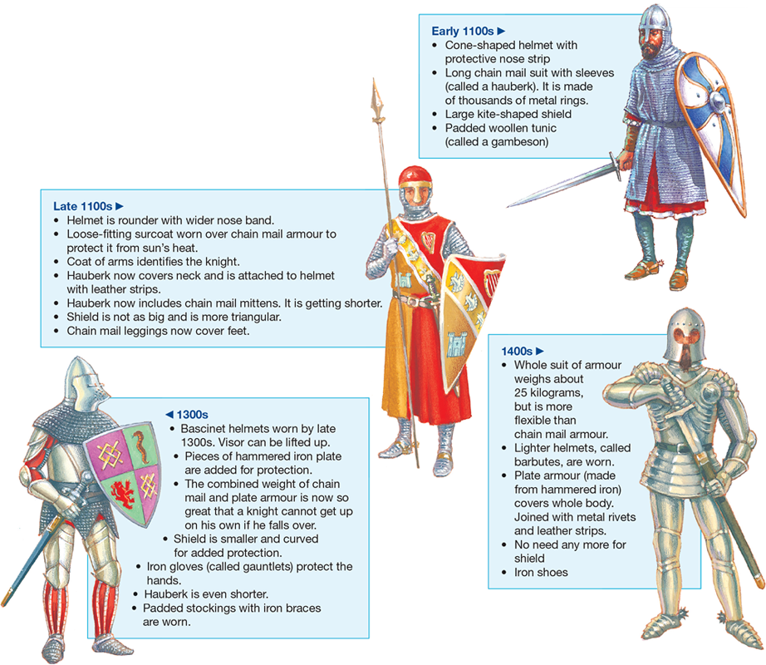

**a.** **What would have been the most vulnerable body part for a knight in the 1100s when fighting foot soldiers? Why?**

|  |
| --- |
|  |
|  |
|  |

**b.** **Why did a knight in the 1400s no longer need a shield?**

|  |
| --- |
|  |
|  |

**5.** **a.** **Why do you think a knight would have to train?**

|  |
| --- |
|  |
|  |
|  |
|  |

**b.** **Describe a well-known training event.**

|  |
| --- |
|  |
|  |
|  |
|  |

**6.** **a.** **Although gunpowder had been invented, why didn’t medieval soldiers use guns very much before about 1500 CE?**

|  |
| --- |
|  |
|  |
|  |
|  |

**b.** **What weapons were useful for long-range attacks?**

|  |
| --- |
|  |
|  |
|  |
|  |

**c.** **Why was it also important for soldiers to carry pikes, swords and axes?**

|  |
| --- |
|  |
|  |
|  |
|  |

**7.** **In your own words, write a short paragraph (two or three sentences) to describe a battlefield scene.**

|  |
| --- |
|  |
|  |
|  |
|  |
|  |
|  |

**8.** **What new technology helped end the usefulness of knights?**

|  |
| --- |
|  |
|  |
|  |
|  |

**9.** **By what century can we say that knights were history?**

|  |
| --- |
|  |
|  |
|  |
|  |